• **Complete the following You Do It exercises from Chapter 2 of our text book.**  (30 points)

* Declaring and Using a Variable
* 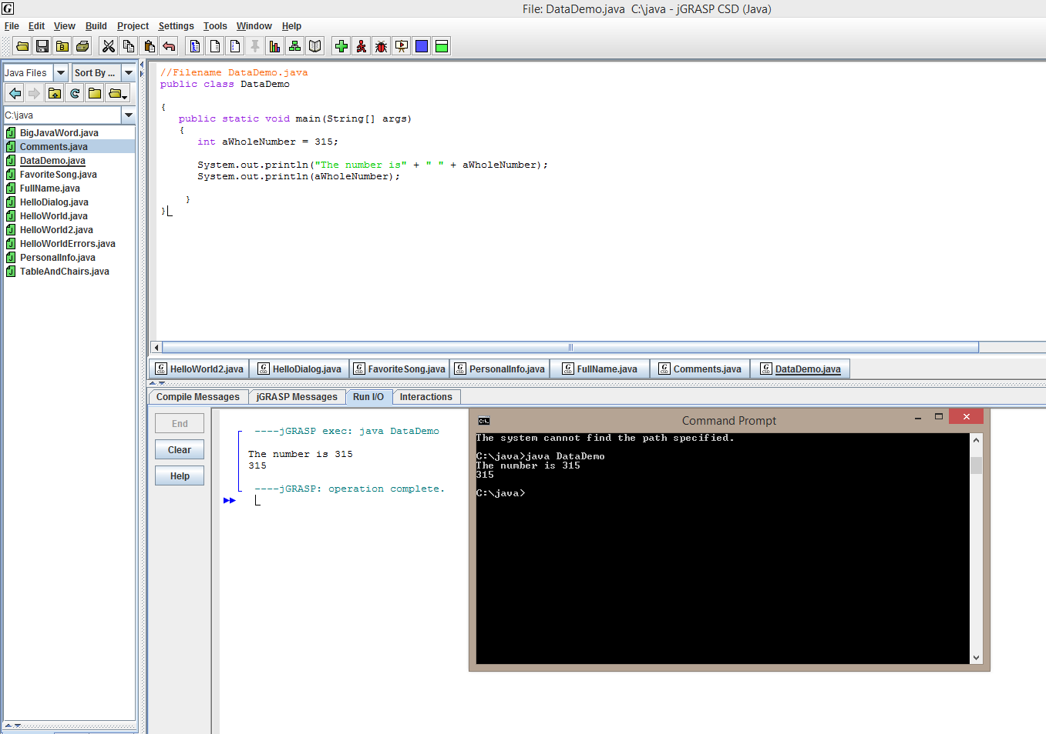
* 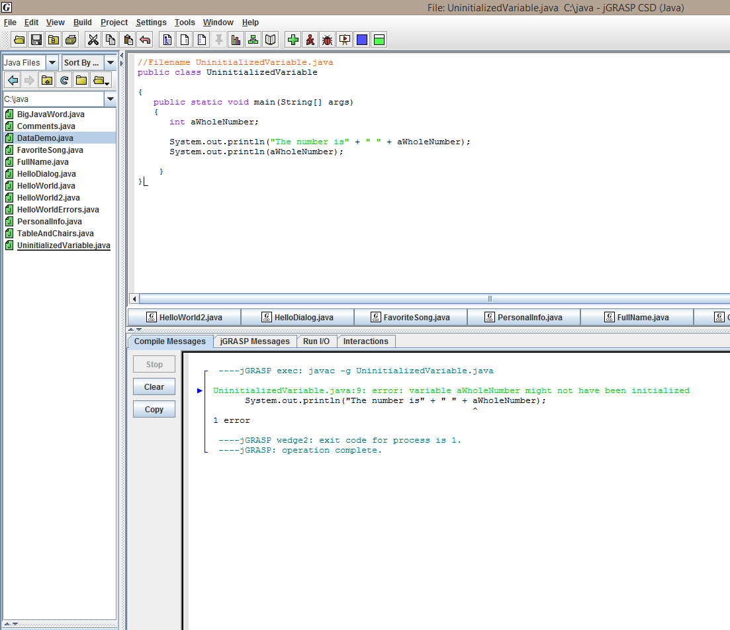
* 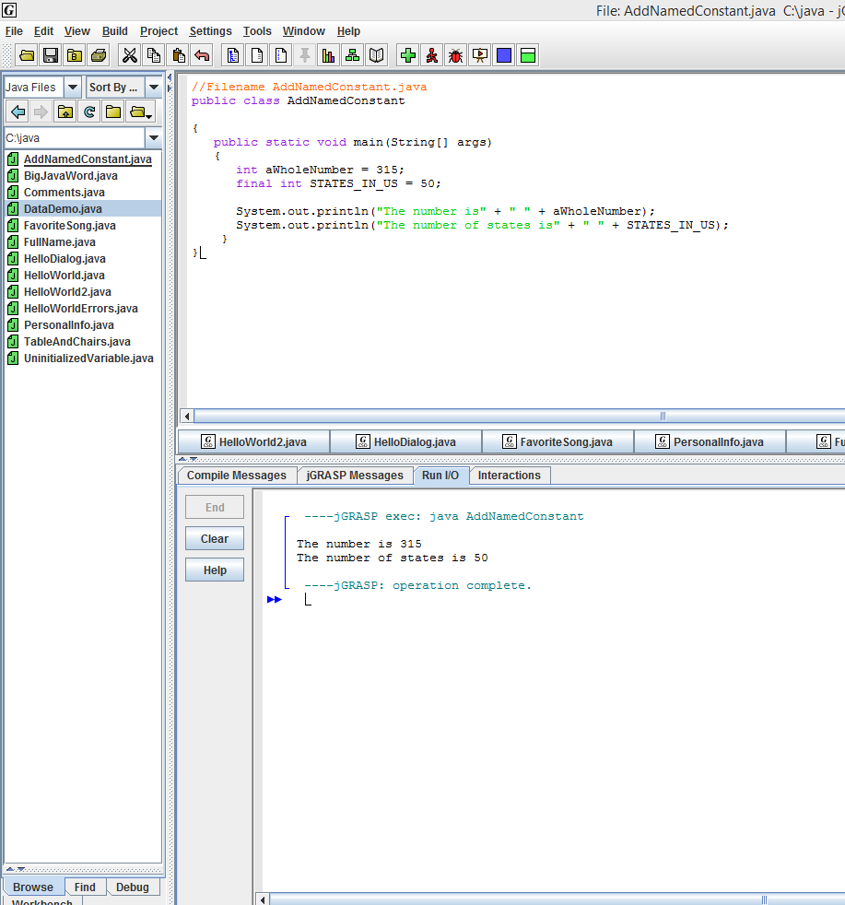
* 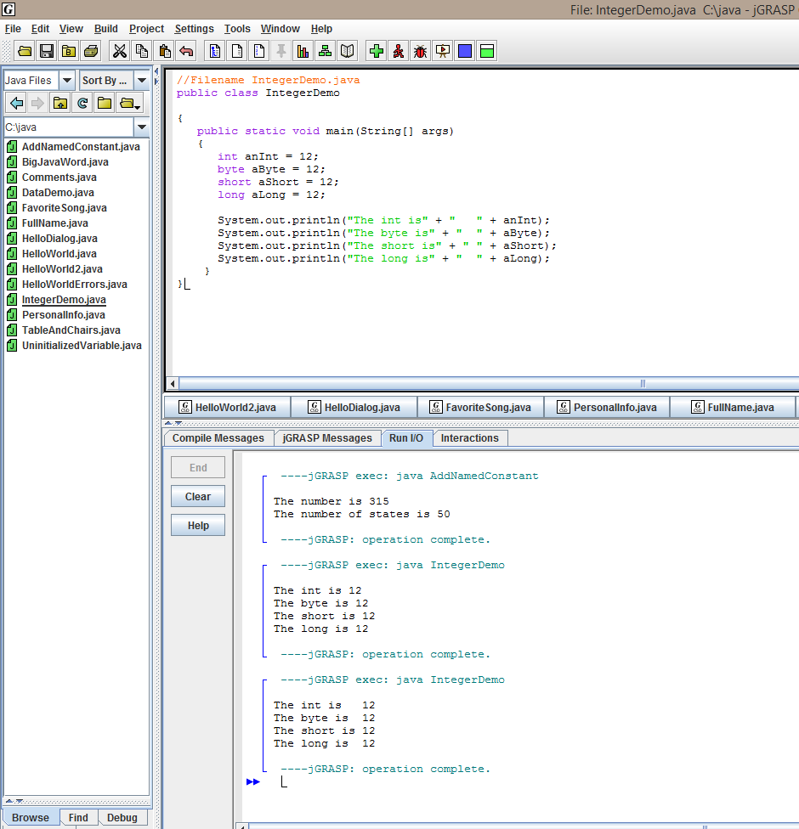
* 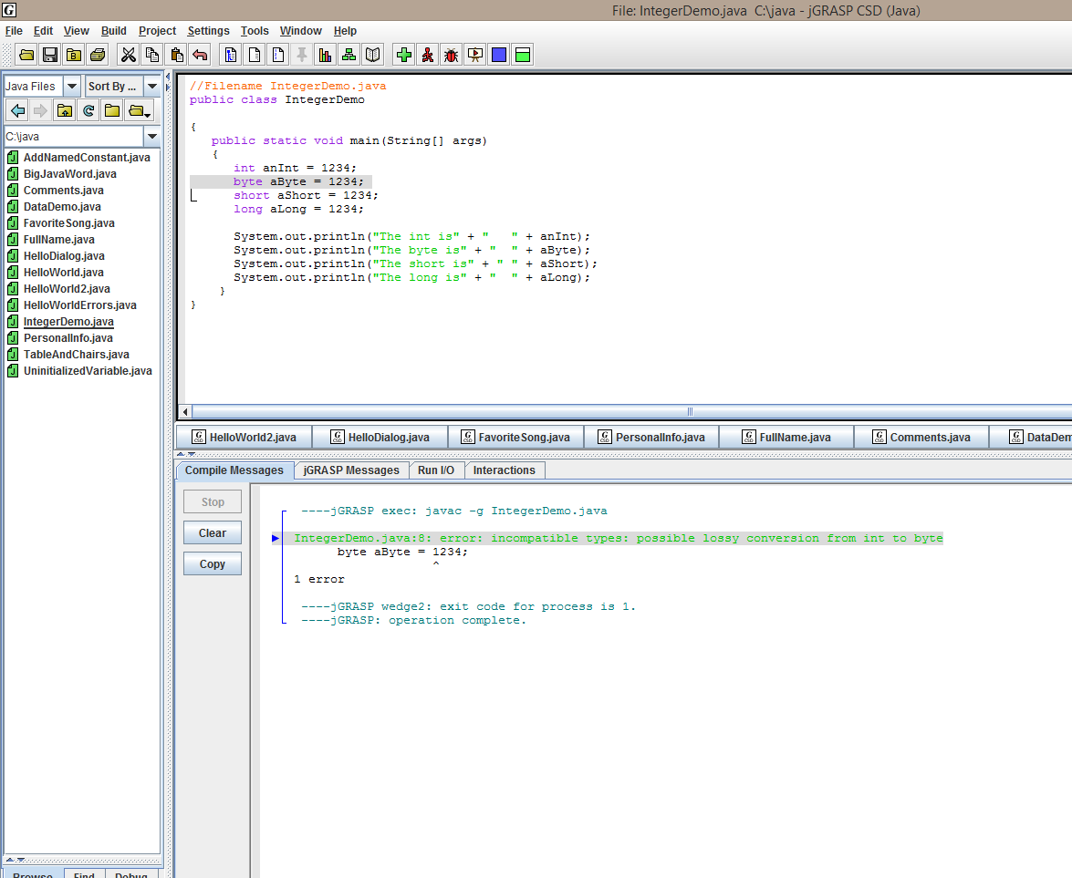
* 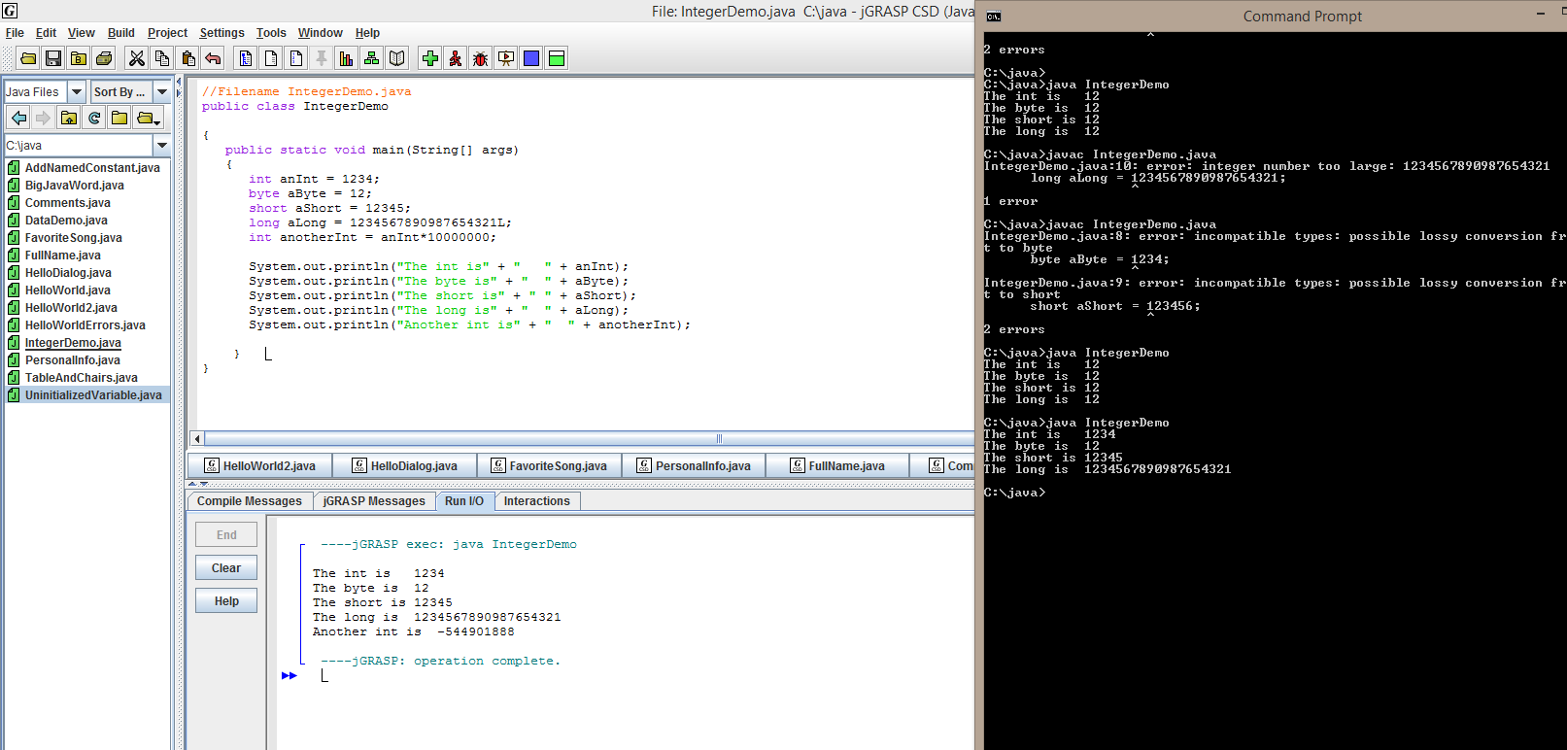
* Working with the char Data Type
* 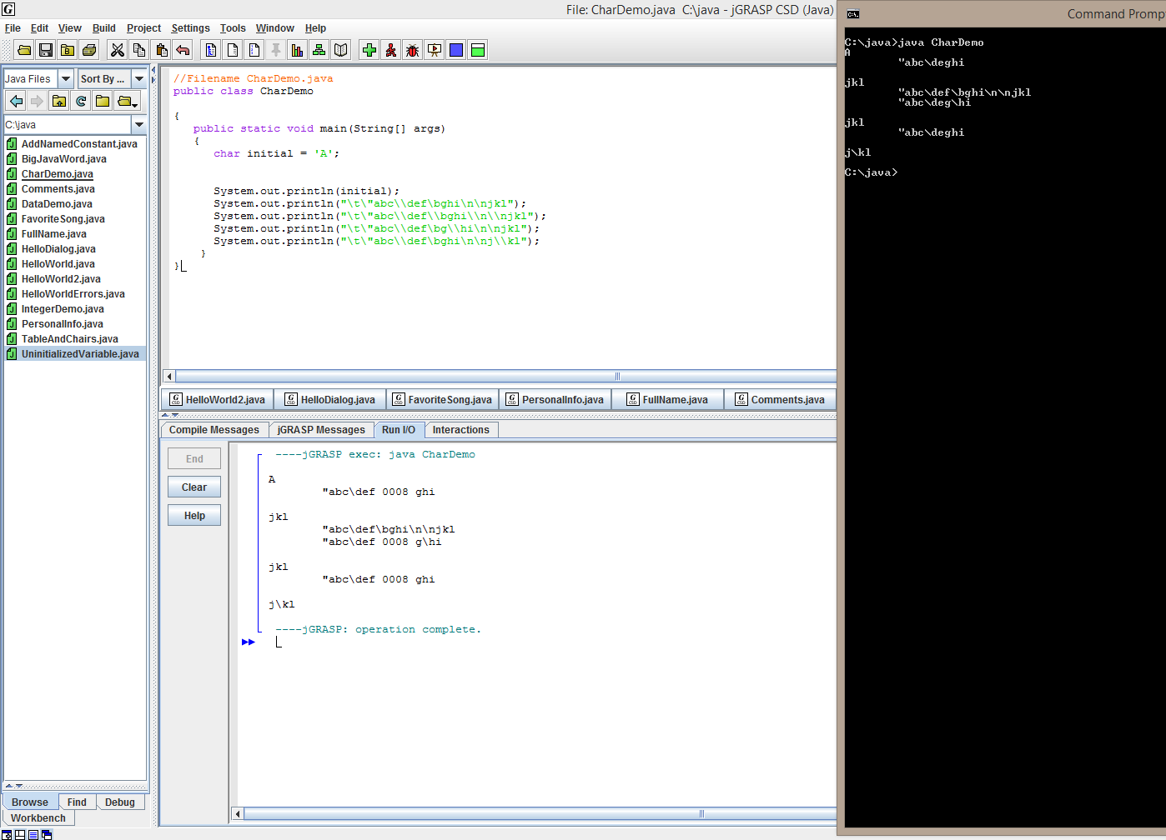
* Accepting User Input

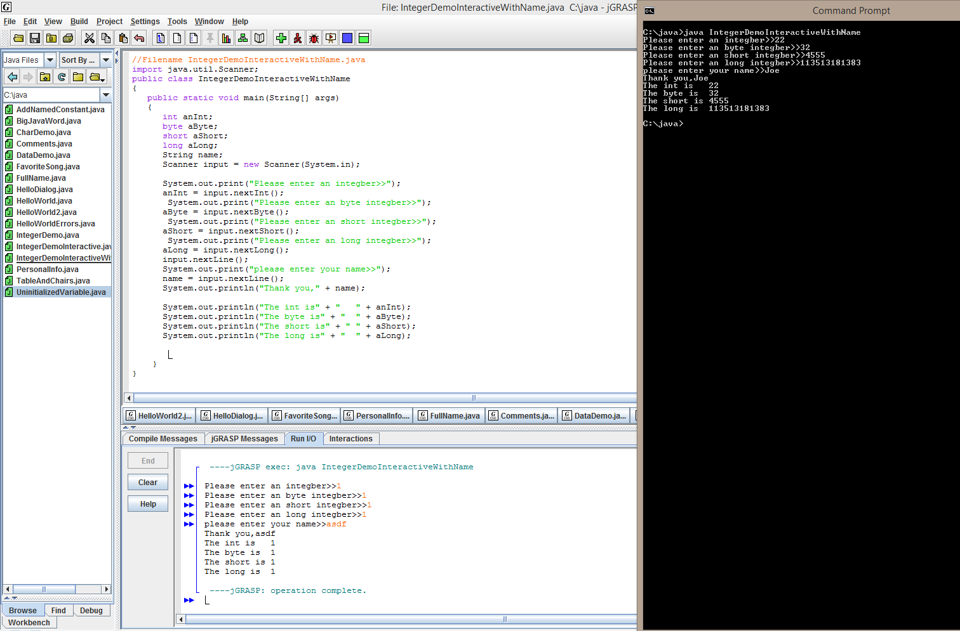

* Using Arithmetic Operators
* 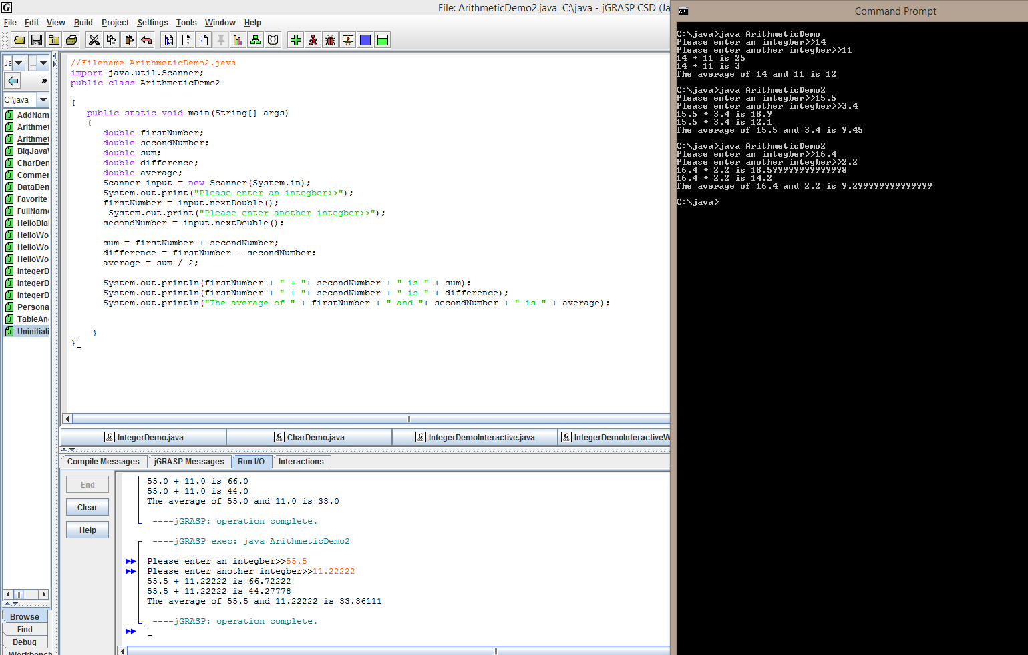
* Implicit and Explicit Casting

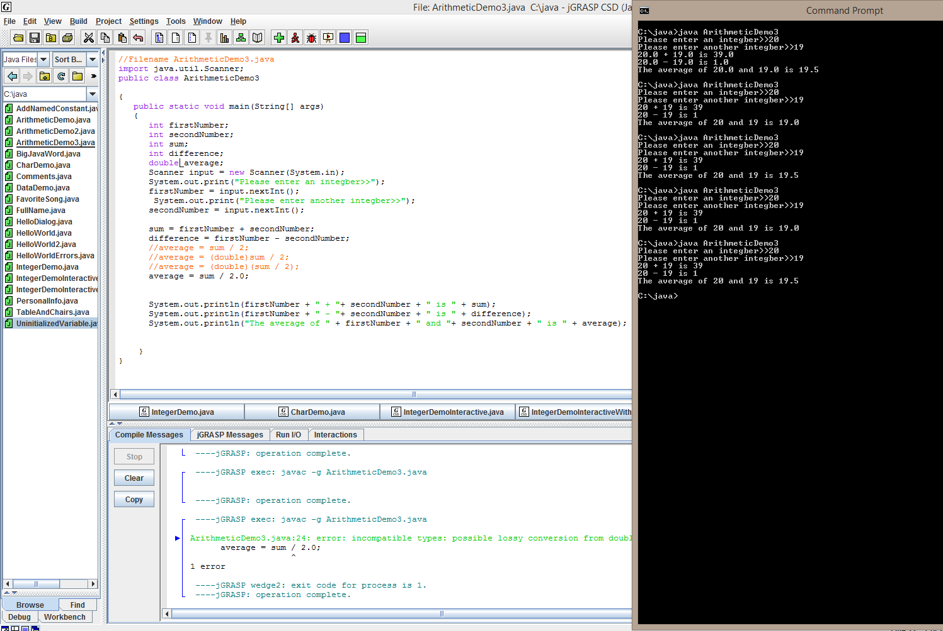

Zip your projects in the folder containing your work and include it with your submission using something such as **U2_YouDoIt_Name.zip**